**DAILY ONLINE ACTIVITIES SUMMARY**

|  |  |  |  |  |  |  |  |
| --- | --- | --- | --- | --- | --- | --- | --- |
| **Date:** | **03/06/20** | | | | **Name:** | **Deena Muthappa** | |
| **Sem & Sec** | **8th sem, A sec** | | | | **USN:** | **4AL16CS028** | |
| **Online Test Summary** | | | | | | | |
| **Subject** | | **Not conducted** | | | | | |
| **Max. Marks** | |  | | **Score** | |  | |
| **Certification Course Summary** | | | | | | | |
| **Course** | **Complete python 3 programming bootcamp** | | | | | | |
| **Certificate Provider** | | | **Udemy** | **Duration** | | | **24hrs** |
| **Coding Challenges** | | | | | | | |
| **Problem Statement: 1) Python program to find GCD of more than two (or array) numbers** | | | | | | | |
| **Status: Completed** | | | | | | | |
| **Uploaded the report in Github** | | | | **Yes** | | | |
| **If yes Repository name** | | | | **deenamuthappa/Coding-Challenges** | | | |
| **Uploaded the report in slack** | | | | **Yes** | | | |

Online Test Details:Not Conducted

Certification Course Details: 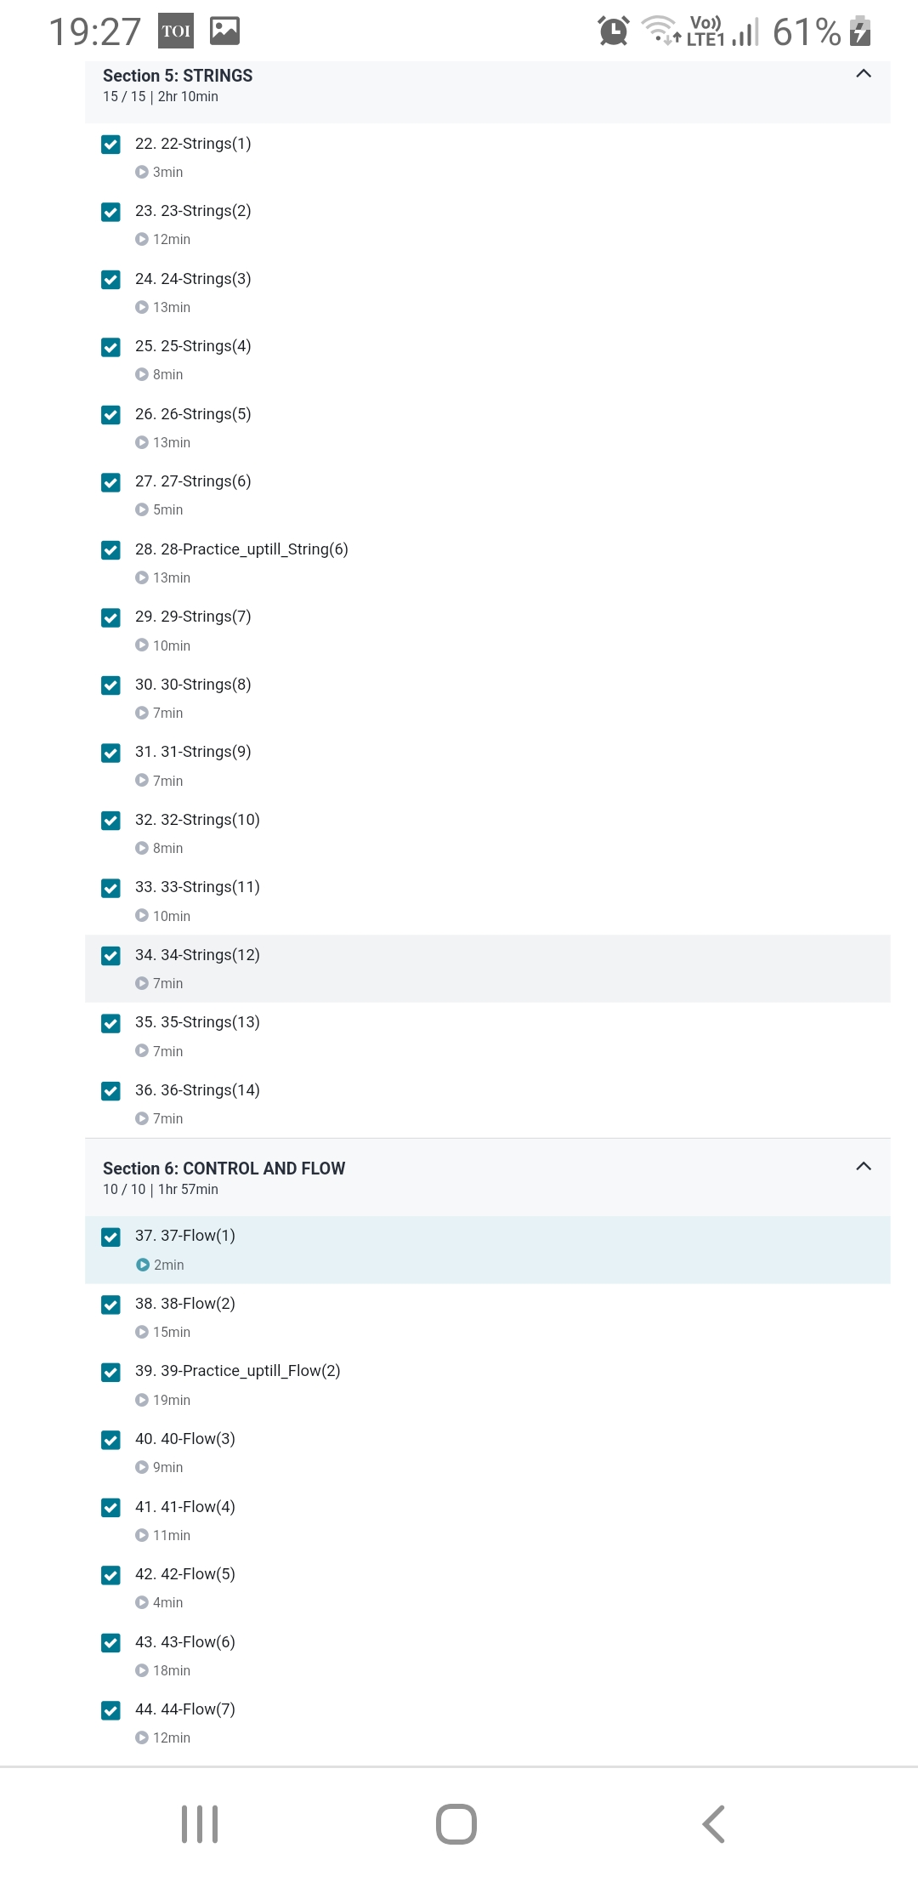

Coding Challenges Details:

1)

def find_gcd(x, y):

while(y):

x, y = y, x % y

return x

l = [2, 4, 6, 8, 16]

num1=l[0]

num2=l[1]

gcd=find_gcd(num1,num2)

for i in range(2,len(l)):

gcd=find_gcd(gcd,l[i])

print(gcd)